BVP Beat Detection
The BVP Beat detection is a part of the Biosig plugin. It consists of 6 classes: The most important one is the BVPBeatDetection. Here a functions to detect beats in a raw signal. The BVPBeatEventSender class uses this detection functions to send events which contain the beat’s features. The features are: minimum, maximum, amplitude, duration, time, energy and power.
There are three different event listener to receive the events and convert them to a stream. The BVPBeatEventRawListener converts the event features to a heart rate, interbeat interval and amplitude signal. The statistical listener uses a window and a statistical function to aggregate the events inside the window. The statistical functions are: Sum, mean, variance, standard deviation and could be applied on the amplitude, heart rate and interbeat interval. The BVPBeatEventRMSSDListener converts the events to an RMSSD signal. RMSSD is the square root of the mean squared differences of successive interbeat intervals. These listener inherit from the BVPBeatEventListenerBase class.

How the BVP beat detection works.
The detection algorithm consists of a statemachine with two states: find minimum and find maximum. In these states, the minimum value and the maximum value of each beat should be found. With these, the amplitude, duration, power, etc. could be calculated.
Switching between these two states depends on the current signal value and the mean, minimum and maximum value of the last seen n samples. With these values, an upper and a lower threshold value is calculated. The upper threshold is defined as: .The lower threshold is defined as: .
If the current signal value is below the lower threshold, the statemachine is switched to the state find minimum. If the current value is above the upper threshold, the statemachine is switched to the state find maximum.
The found minima and maxima are saved with their time and value.
Once the statemachine is in the state find maximum and is about to switch to the state find minimum, because the value went below the lower threshold, a new beat is found.
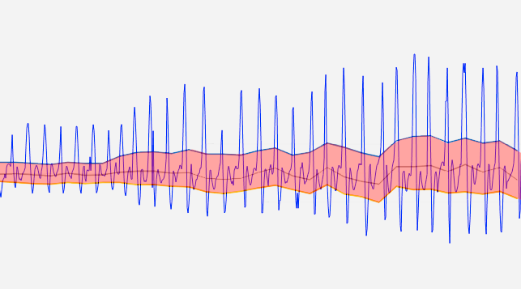
Figure 1: The upper and the lower threshold. Between them the "ignored" area.
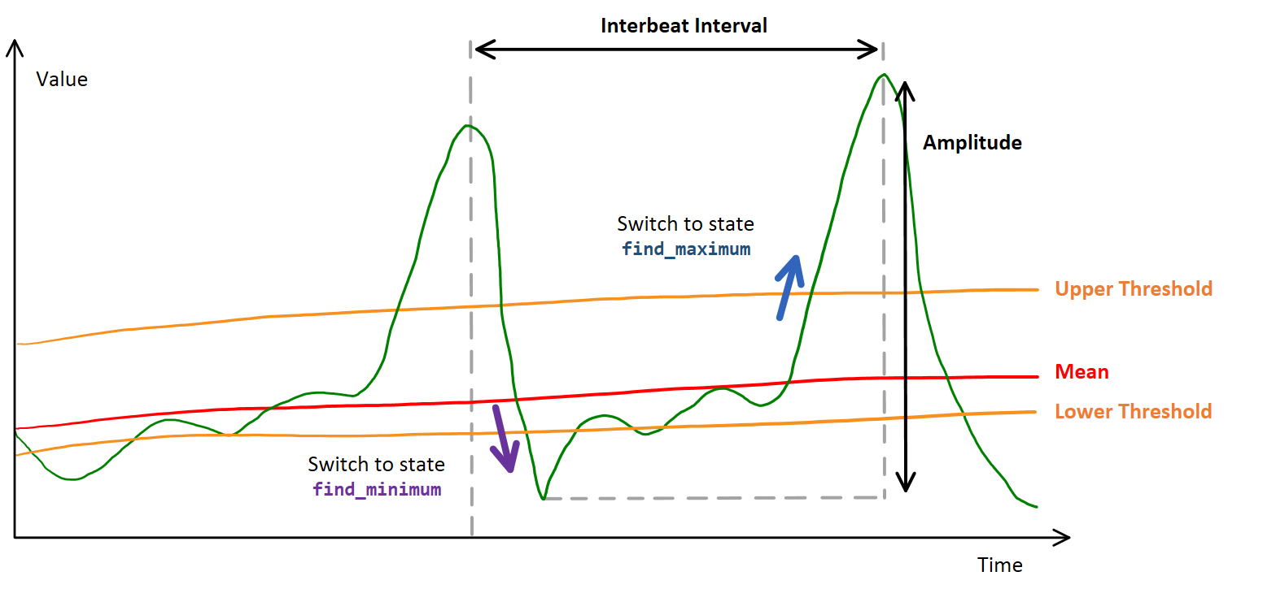
Figure 2: Concept of the detection algorithm.

